A Research Report Submitted for the Award of the Mini Research Grants of Research Management Committee of Durgalaxmi Multiple Campus, Attariya, Kailali

Submitted by
Sabitri Bhatta
Head Assistant, Durgalaxmi Multiple Campus Durga Khadka
M. A. III semester, Durgalaxmi Multiple Campus

Submitted to
Research Management Committee Durgalaxmi Multiple Campus Attariya Kailali

2026

A Research Report Submitted for the Award of the Mini Research Grants of Research Management Committee of Durgalaxmi Multiple Campus, Attariya Kailali

Submitted by
Sabitri Bhatta
Head Assistant, Durgalaxmi Multiple Campus Durga Khadka
M. A. III semester, Durgalaxmi Multiple Campus

Submitted to
Research Management Committee Durgalaxmi Multiple Campus Attariya Kailali

2026

Abstract
Graduate employability and career satisfaction have become central indicators of the quality and relevance of higher education. Tracer studies are widely recognized as effective tools for assessing and know how graduates transition from academic institutions into the labor market exhilarating and incredibly overwhelming and how they evaluate their professional lives after graduation. This aimed to investigate the employment trends and career satisfaction of graduates from Durgalaxmi Multiple Campus, Attariya, Kailali, Nepal, over a Three-year period from 2021 to 2023. The study included graduates from both Bachelor’s and Master’s degree programs of all faculties such as Management, Education and Humanities and Social Sciences.
Using a quantitative survey through tracer study design, the research collected quantitative data through structured questionnaires related with their carrier. The quantitative component focused on employment status, type of employment, sectoral distribution, job relevance to academic qualifications, income level, and time taken to secure employment. Similarly, the study examined graduates’ perceptions of career satisfaction, challenges faced during job transition, competition level and the perceived relevance of campus education to workplace demands.
The findings provided evidence-based insights for curriculum improvement, institutional planning, professional networking, skills oriented academic knowledge, social inequality in access to jobs, career guidance services, and policy formulation at Durgalaxmi Multiple Campus. Moreover, the study is expected to contribute to the limited body of tracer study research in the context of Nepalese higher education, particularly for campuses located outside major metropolitan areas.

Approval Letter
Ms. Sabitri Bhatta and Ms. Durga Khadka have defended the research entitled, Employment Trends and Career Satisfaction of Graduates: A Tracer Study Based Research of Durgalaxmi Multiple Campus, successfully.

………………………………. …………………….
(Research Committee Head)

……………………………… …………………….
(Research Committee Member)

…………………………….. ……………………
(Research Committee Member)

Date: ……………………………

Table of Contents
Abstract i
Approval Letter ii
Chapter 1: Introduction 1
Background of the Study 1
Significance of the Study 2
Statement of the Problem 2
Objectives of the Study 3
Research Questions 3
Delimitations of the Study 3
Operational Definitions of Key Terms 3
Chapter 2: Review of Related Literature 4
The Concept of Employability 4
Empirical Studies 5
Research Gap 8
Chapter 3: Research Methodology 13
Research Design 13
Population and Sampling 13
Data Sources 13
Research Instruments 14
Data Collection Procedures 14
Data Analysis 14
Validity and Reliability 15
Ethical Considerations 15
Chapter 4: Results 16
References 29
Appendices 16
Appendix I: Sample Survey Questionnaire 16
Appendix II: Sample Consent Letter for Participation 17

Chapter 1: Introduction

Background of the Study
Higher education institutions across the world are increasingly evaluated not only on academic standards theory-based curriculum but also on their ability to prepare graduates for meaningful employment, access to desire and sustainable careers. The rapid transformation of labor markets, driven by globalization, technological change, and shifting economic structures, has placed new demands on universities and campuses to ensure that graduates possess relevant knowledge, skills, and professional competencies (Harvey, 2010).
Tracer studies have emerged as a practical and reliable research approach for examining graduate outcomes in reality. Such studies trace graduates after they leave an institution to assess their employment status, career progression, job satisfaction, and perceptions of the relevance of their academic training (Schomburg, 2016). These studies provide valuable feedback to institutions, policymakers, and stakeholders by highlighting strengths, gaps, and areas for improvement within academic programs.
In Nepal, higher education has expanded significantly over the past two decades, with the establishment of new universities, constituent campuses, and affiliated colleges. Despite this expansion, concerns remain regarding graduate employability, skill mismatch, underemployment, and job satisfaction (Bista, 2020). Many graduates face difficulties in securing employment that aligns with their qualifications, leading to frustration, migration, or acceptance of jobs unrelated to their field of study.
Durgalaxmi Multiple Campus, located in Sudurpaschim province, Kailali district, is an important higher education institution serving students from diverse geographical socio-economic backgrounds in Sudurpashchim Province. The campus offers bachelor’s and master’s degree programs under the affiliation of national universities. Over the years, it has produced a significant number of graduates who are now engaged in various sectors, including education, Business Organization, technology-oriented agriculture, government service, private organizations, self-employment, and foreign employment. However, there has been no systematic tracer study to document their employment trends or assess their level of career satisfaction.
This research seeks to fill that gap by conducting a comprehensive tracer study of graduates from Durgalaxmi Multiple Campus over a five-year period from 2021 to 2023. By examining both employment outcomes and subjective career satisfaction, the study aims to provide a holistic understanding of graduates’ post-academic experiences.

Significance of the Study
The significance of this study lies in its potential contribution to institutional improvement, policy planning, and academic understanding, curriculum of graduate outcomes. By systematically examining the employment trends and career satisfaction of graduates from Durgalaxmi Multiple Campus, the study can provide empirical evidence on how effectively the campus prepares students for the labor market. The findings can help campus administrators and academic departments identify strengths and gaps in existing programs, supporting informed decisions related to curriculum revision, teaching practices, and career support services. At the policy level, the study might offer localized data that can assist university authorities and education planners in aligning higher education programs with regional employment opportunities and national development priorities. Academically, the research can add to the limited body of tracer study literature in the Nepalese context, particularly focusing on a regional multiple campus. Furthermore, the study may benefit current and prospective students by offering realistic insights into employment prospects and career satisfaction associated with different academic programs, thereby supporting informed educational and career choices.

Statement of the Problem
Despite the growing emphasis on employability and outcome-based education, Durgalaxmi Multiple Campus currently lacks empirical data on the professional trajectories of its graduates. There is limited information on key issues such as:
- The proportion of graduates who are employed, unemployed, or underemployed
- The types of jobs graduates secure after completing their degrees
- The relevance of academic programs to graduates’ current occupations
- Graduates’ satisfaction with their careers and professional growth
The absence of such data creates challenges for institutional decision-making. Curriculum revisions, teaching strategies, and career support services are often implemented without direct evidence from graduates’ real-world experiences. Furthermore, policymakers and stakeholders lack localized research-based insights into how higher education contributes to employment and career development in the region. Therefore, there is a clear need for a systematic tracer study that investigates employment trends and career satisfaction among graduates of Durgalaxmi Multiple Campus. This study seeks to address this gap by generating reliable data and analysis that can inform academic, administrative, and policy-level improvements.

Objectives of the Study
The study has the following two objectives:
- To examine the employment trends of bachelor’s and master’s degree graduates of Durgalaxmi Multiple Campus from 2021 to 2023.
- To assess the level of career satisfaction of graduates of Durgalaxmi Multiple Campus in relation to their educational qualifications.

Research Questions
The study answered the following two research questions:
- What are the employment trends of bachelor’s and master’s degree graduates of Durgalaxmi Multiple Campus during the period from 2021 to 2023?
- To what extent are graduates of Durgalaxmi Multiple Campus satisfied with their careers after graduation?

Delimitations of the Study
The study focused on graduates from Durgalaxmi Multiple Campus who completed bachelor’s or master’s degrees between 2021 and 2023. It examined employment trends and career satisfaction but did not evaluate individual academic performance, cooperative behaviors or institutional ranking. The research is limited to one campus, which may affect the generalizability of findings to other institutions.

Operational Definitions of Key Terms
Tracer Study. A research approach that tracks graduates after completion of their studies to assess employment outcomes and career development.
Employment Trends. Patterns related to employment status, sector, job type, and duration after graduation.
Career Satisfaction. Graduates’ subjective evaluation of their career progress, job fulfillment, and professional growth.
Graduate. A student who has successfully completed a bachelor’s or master’s degree program in humanities, management and education.

Chapter 2: Review of Related Literature
Graduate outcomes research has increasingly foregrounded employability and career satisfaction as central indicators of the quality and higher education relevance in today’s dynamic labor markets. Tracer studies, which systematically track graduates after completion of their studies to assess how they transition into employment and how they evaluate their careers, have become a widely accepted tool for institutional self-evaluation and planning (Schomburg, 2016). These studies provide direct evidence on employment patterns, sectors of engagement, and subjective evaluations of career success, thereby offering insights that go beyond traditional academic metrics. Globally, tracer studies have demonstrated that employment and satisfaction outcomes are deeply shaped by academic preparation, experiential learning, labor market conditions, and personal attributes (Wilton, 2012; Bennett et al., 2015). In the context of Nepal, with its unique labor market structures and regional disparities, tracer studies are particularly necessary to inform curriculum reforms, career services, skills development curriculum and policy decisions. The Concept of Employability
The concept of employability has evolved substantially over time. Initially rooted in Human Capital Theory, employability was understood as the economic value of formal education and credential attainment that boosts workers’ productivity and labor market prospects (Becker, 1964; Green & McIntosh, 2007). Human Capital Theory posits that higher educational attainment should correlate with higher employment rates and better earnings because education enhances cognitive skills and knowledge. In tracer studies, this perspective helps explain why graduates with higher qualifications often show better employment outcomes. However, the human capital perspective has limitations, as it tends to assume a direct and linear pathway from education to employment without fully recognizing the role of labor market structures, discrimination, economic cycles, and the quality of education itself (Brown et al., 2003).
Contemporary scholarship therefore emphasizes a broader, multi-dimensional understanding of employability that integrates human capital with social capital, psychological attributes, and adaptive competences (Fugate et al., 2004; Pool & Sewell, 2007). Employability is now often defined not merely as the ability to secure employment but as a combination of knowledge, skills, attitudes, personal agency, and networks that support sustainable career development (Knight & Yorke, 2004). This broader framing allows researchers to capture the complexity of graduates’ transitions into work and

account for contextual variables such as industry demands, socio-economic backgrounds, and institutional support systems.

Empirical Studies
International evidence consistently shows that alignment between academic preparation and job relevance strongly influences career satisfaction. Engineering graduates in the United States who worked in roles closely tied to their field of study reported higher career satisfaction than those in unrelated roles (Knouse et al., 2013), and European studies conclude that graduates who perceive their education as directly applicable to their jobs exhibit greater satisfaction and confidence in their professional futures (Tomlinson, 2017). These findings suggest that graduates’ subjective assessments depend not only on whether they are employed but on the quality of their employment and the degree to which their careers enable personal and professional fulfillment.
Empirical studies in Nepal reflect this broader reality. A tracer study conducted at Balkumari College found that although most graduates secured employment within a few years of graduation, many worked in sectors not directly aligned with their academic majors, indicating both employability and structural labor market challenges (Chhetri & Sedai, 2019). The study further showed that academic preparation and curriculum relevance played significant roles in enhancing employability outcomes, reinforcing the need for curricula that connect more directly with real-world job demands. Another recent study examining factors influencing graduate employability in Nepal found that teamwork and problem-solving skills, practical training, and university curricula were significant predictors of employability, accounting for nearly half of the variance in measured employability outcomes (Khadka, 2025). This suggests that developing soft skills and experiential learning opportunities are key institutional responsibilities in Nepalese higher education.
Research from Butwal also contributes important insights by showing that graduate employability is strongly associated with multiple forms of capital, including psychological, social, cultural, and human capital, with positive and significant effects on perceived employability (Gyawali, 2025). This aligns with international literature emphasizing that employability capital extends beyond academic credentials and is shaped by a constellation of personal and contextual resources. Additionally, a study on engineering graduates’ employability from the perspective of employers highlighted that practical and enterprising skills, proactiveness, and workplace readiness were essential for employability, while traditional examination systems focused on memorization were seen

as inadequate (Sharma, 2023). These employer perspectives illustrate that Nepali graduates face expectations for higher-order competencies that are not always emphasized within standard curricula, underscoring the need for curriculum reforms oriented toward real-world competencies.
Another example of Nepal-based evidence comes from the employment status report of Kalika Multiple Campus graduates, which showed that while a large proportion of graduates were employed, an overwhelming majority were in temporary positions with limited job security (Gautam, 2025). This pattern resonates with broader concerns about job quality in Nepal and highlights the importance of differentiating between mere employment and meaningful, sustainable employment. The study also pointed out that graduates identified the need for enhanced digital skills training and stronger industry linkages, suggesting institutional gaps in preparing students for evolving job market demands. Additionally, an unpublished M.Phil. dissertation on perceived employability skills of diploma graduates in Kathmandu Valley found that core and generic skills were often inadequate and that differences in perceived skills existed across ethnicity and institutional contexts (Panthee, 2025). These findings reinforce the idea that employability cannot be reduced to formal qualifications alone, but must consider graduates’ broader competencies and contextual challenges.
While the literature on employability is substantial, the construct of career satisfaction a related but distinct domain focuses on graduates’ subjective evaluations of their professional trajectories. Career satisfaction encompasses graduates’ judgments about their job quality, opportunities for growth, alignment of work with personal goals, and overall contentment with their professional life (Greenhaus et al., 1990). According to the Person–Environment Fit framework, individuals experience higher satisfaction when their skills, values, and needs are congruent with their work environments (Kristof-Brown et al., 2005). This perspective has been vital in understanding why some graduates, despite being employed, may feel unfulfilled if their roles do not match their qualifications or aspirations.
Empirical studies in Nepal that explicitly measure career satisfaction are less common, but emerging evidence points to similar patterns. A Kathmandu Valley study revealed that graduates who perceived strong alignment between their education and employment reported higher career satisfaction, while those in informal or unstable jobs expressed lower satisfaction (Aryal, 2021). Another study on science and management graduates in Nepal found positive correlations between satisfaction and variables such as

job security, professional development opportunities, and adequate income, further highlighting the importance of job quality for long-term satisfaction (Gurung & Shrestha, 2022). These findings align with international work, suggesting that beyond employability, career satisfaction reflects graduates’ assessments of how well their jobs allow them to meet personal and professional goals.
Some Nepalese tracer studies also directly document graduates’ satisfaction with current employment status. A recent tracer report found that a majority of employed graduates reported moderate to high levels of job satisfaction across organizational types, with particularly high satisfaction among those in NGO/INGO positions and public organizations (Tracer Study Report, 2025). This pattern suggests that organizational context matters for career satisfaction, and that institutional type can shape graduates’ perceptions of their work experiences. Additionally, a broader tracer study showed that master’s graduates exhibited higher employment rates and different employment distributions compared to bachelor’s graduates, suggesting that higher qualifications may support both career opportunities and potentially satisfaction outcomes (Birendra Multiple Campus Report, 2025). These findings underscore the importance of nuanced measurement that captures both employment trends and subjective satisfaction across different graduate cohorts.
Despite valuable insights, there remain gaps in the empirical literature on employability and career satisfaction in Nepal. Many tracer studies focus primarily on basic employment outcomes, such as employment status and sector distribution, but fewer explore graduates’ long-term career trajectories and satisfaction in depth. Moreover, existing research is often limited to specific institutions or regions, making it difficult to generalize findings across diverse contexts within Nepal. There is also a need for longitudinal data that tracks changes in employment trends and satisfaction over time, especially given the dynamic socio-economic and labor market conditions facing Nepalese graduates.
In summary, the literature indicates that employability and career satisfaction are distinct yet interconnected constructs that shape graduates’ professional outcomes. Employability encompasses a range of competencies and contextual resources that facilitate labor market entry and sustainability, while career satisfaction reflects how graduates perceive and evaluate their ongoing professional lives. Empirical evidence from Nepal underscores that academic preparation, practical training, soft skills, and institutional support are key determinants of employability, while job quality, alignment

between education and work, and opportunities for growth influence career satisfaction. However, there is a need for more comprehensive research that integrates these constructs within tracer studies that examine employment trends and career satisfaction over extended periods, particularly in regional contexts such as Durgalaxmi Multiple Campus.
Research Gap
The literature shows that graduate employability and career satisfaction are shaped by multiple factors: academic preparation, transferable skills, institutional support, and personal resources. Theoretical perspectives such as Human Capital Theory, life-span career development, and employability capital provide frameworks to understand how education contributes to employment outcomes. Career satisfaction theories build on job satisfaction and psychological models to explain subjective evaluations of career success.
Empirical evidence from Nepal is growing but remains limited in longitudinal and career satisfaction dimensions. Most Nepalese tracer studies focus on descriptive employment status without deeper analysis of graduates’ subjective experience and long-term trends. This points to an important gap: a comprehensive tracer study that integrates employment patterns over time with graduates’ perception of their career satisfaction and education relevance.

Chapter 3: Research Methodology

Research Design
This study employed a quantitative survey design through a tracer study to investigate employment trends and career satisfaction among graduates of Durgalaxmi Multiple Campus from 2021 to 2023. Tracer studies are widely used in higher education research to systematically track graduates’ career paths, assess their employment outcomes, and evaluate the relevance of academic programs to labor market demands. By adopting a quantitative survey approach, this research gathered measurable data on employment rates, job types, sectors, and levels of career satisfaction, enabling statistical analysis of trends and relationships. The survey-based tracer study design allows for the collection of standardized data from a large number of graduates, ensuring representativeness and generalizability of the findings while providing insights to inform institutional planning, curriculum development, and career guidance programs.

Population and Sampling
The target population for this study includes all graduates of bachelor’s and master’s programs from Durgalaxmi Multiple Campus who completed their studies between 2021 and 2023. According to preliminary records from the campus, this encompasses approximately Six Hundred and Twenty-Six (626) graduates. The study adopted a census approach, attempting to survey all reachable graduates to ensure comprehensive coverage and reliable statistical analysis. Efforts was made to include graduates across all programs and years of graduation to capture a representative sample of employment experiences and career satisfaction levels.

Data Sources
This study utilized both primary and secondary data sources. Primary data were collected through an online structured questionnaire distributed to graduates, capturing information about employment status, job characteristics, duration to first employment, relevance of academic training, and career satisfaction. Semi-structured interviews were conducted with selected graduates to gain a deeper understanding of their career experiences, challenges, and perceptions regarding the relevance of their education to current employment. Secondary data included academic and alumni records from Durgalaxmi Multiple Campus, which provided historical information about graduates and help identify trends. Additionally, any existing tracer study reports or institutional labor market analyses was reviewed to validate and contextualize findings.

Research Instruments
The online questionnaire was designed in both Nepali and English and consisted of structured questions to capture quantitative data. It included items that measure current employment status, type of employment, sector of employment, duration between graduation and first job, and the perceived relevance of the academic program to the graduate’s career. Career satisfaction was assessed using a five-point Likert scale ranging from “Very Satisfied” to “Very Dissatisfied.” The questionnaire was pilot tested on a small group of alumni to ensure clarity, reliability, and appropriateness of the items. The semi-structured interview guided graduates to express their experiences regarding employment, challenges in securing jobs, satisfaction with current careers, and suggestions for curriculum or career support improvements. Interviews were audio-recorded with participants’ consent and transcribed for detailed analysis.

Data Collection Procedures
Data collection began with obtaining ethical clearance from the Institutional Review Committee and permission from Durgalaxmi Multiple Campus to access graduate records. The database of graduates from 2021 to 2023 were compiled, including all available contact information. The online questionnaire was then distributed to all reachable graduates using multiple platforms, including email, WhatsApp, and social media. Two follow-up reminders were sent over a three-week period to improve response rates and ensure sufficient participation for statistical analysis. Graduates were be informed about the purpose of the study, the voluntary nature of participation, and the confidentiality of their responses.

Data Analysis
Collected data were coded and analyzed using statistical software such as SPSS and Microsoft Excel. Descriptive statistics, including frequencies, percentages, means, and standard deviations, were summarized key findings such as employment rates, sectors of employment, types of jobs, and levels of career satisfaction. Inferential statistics, including chi-square tests and correlation analysis, examined the relationships between graduates’ academic programs, their employment outcomes, and career satisfaction. Findings were presented through tables, graphs, and charts to clearly depict trends and patterns. The quantitative survey through the tracer study approach enabled the identification of critical gaps between academic preparation and employment outcomes while providing evidence-based recommendations for institutional improvement.

Validity and Reliability
The validity of the research instruments was ensured through review by academic experts and pilot testing with a small sample of graduates. Pilot testing helped identify ambiguous or unclear items and allowed refinement of both the questionnaire and the interview guide. Reliability of the quantitative instrument was checked using internal consistency measures such as Cronbach’s alpha for Likert-scale items. For qualitative data, inter-coder reliability was ensured by having multiple researchers independently code interview transcripts, resumes and resolve discrepancies through discussion, thus maintaining consistency in analysis.

Ethical Considerations
The study adhered to strict ethical standards throughout the research process. Participation was voluntary, with informed consent obtained from all respondents. Confidentiality and anonymity were maintained, and no identifying information was included in any report or publication. Data were securely stored in password-protected files and used exclusively for research purposes. Findings were presented in aggregate form to prevent identification of individual graduates and to maintain professional and ethical standards in reportin

Chapter 4: Results
This chapter presents the findings of the Graduate Tracer Study conducted by Durgalaxmi Multiple Campus on its 2018 graduates. All sixty (60) graduates of the cohort were successfully traced and surveyed, yielding a 100 percent response rate. The results are organized under six themes: the demographic profile of the graduates; their employment and further-study status; the perceived quality and relevance of the programs; the contribution of the programs to personal and professional development; issues related to teaching and learning; and satisfaction with institutional facilities. Quantitative responses are summarized in tables and illustrated with figures, followed by a concise interpretation of each result.

Demographic Profile of the Graduates-2021
The 2021 cohort consisted of a total of 223 graduates. The campus academic profile during this period was highly dominated by the Management stream
Table 1: Academic Stream Distribution (2021)
Faculty / Program Stream | Degree Level | Number of  Graduates | Cohort Share (%)
Management | (BBS) | 165 | 74.0
Education | (B.Ed) | 24 | 10.8
Humanities | (BA) | 16 | 7.2
Post-Graduate | Master's Degrees | 18 | 8.1
Total Cohort | — | 223 | 100.0

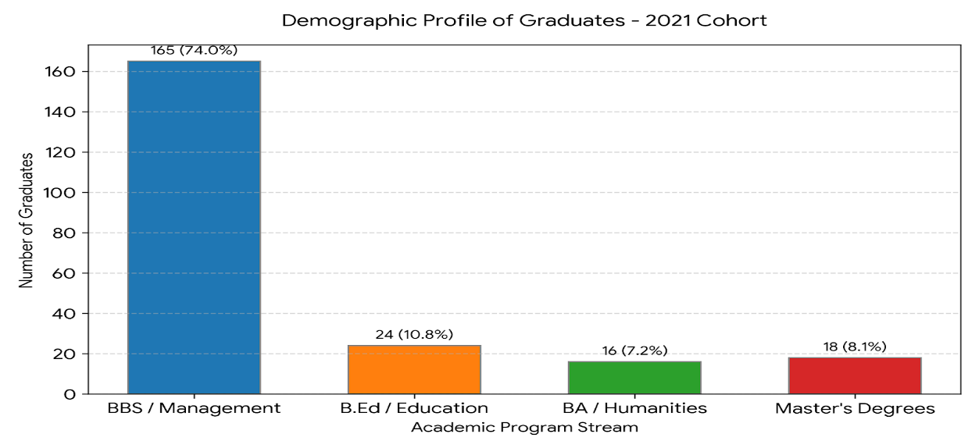

2.2. Demographic Profile of Graduates — 2022

The 2022 graduating cohort totaled 204 students. This year marked the beginning of a diversification process, with increased retention and final completions in both the Education and Humanities faculties.

Table 1.2: Academic Stream Distribution (2022)
Faculty / Program Stream | Degree Level | Number of Graduates | Cohort Share (%)
Management | (BBS) | 105 | 51.5%
Education | (B.Ed) | 45 | 22.1%
Humanities | (BA) | 30 | 14.7%
Post-Graduate | (M.Ed / MBS) | 24 | 11.8%
Total Cohort | — | 204 | 100.0%

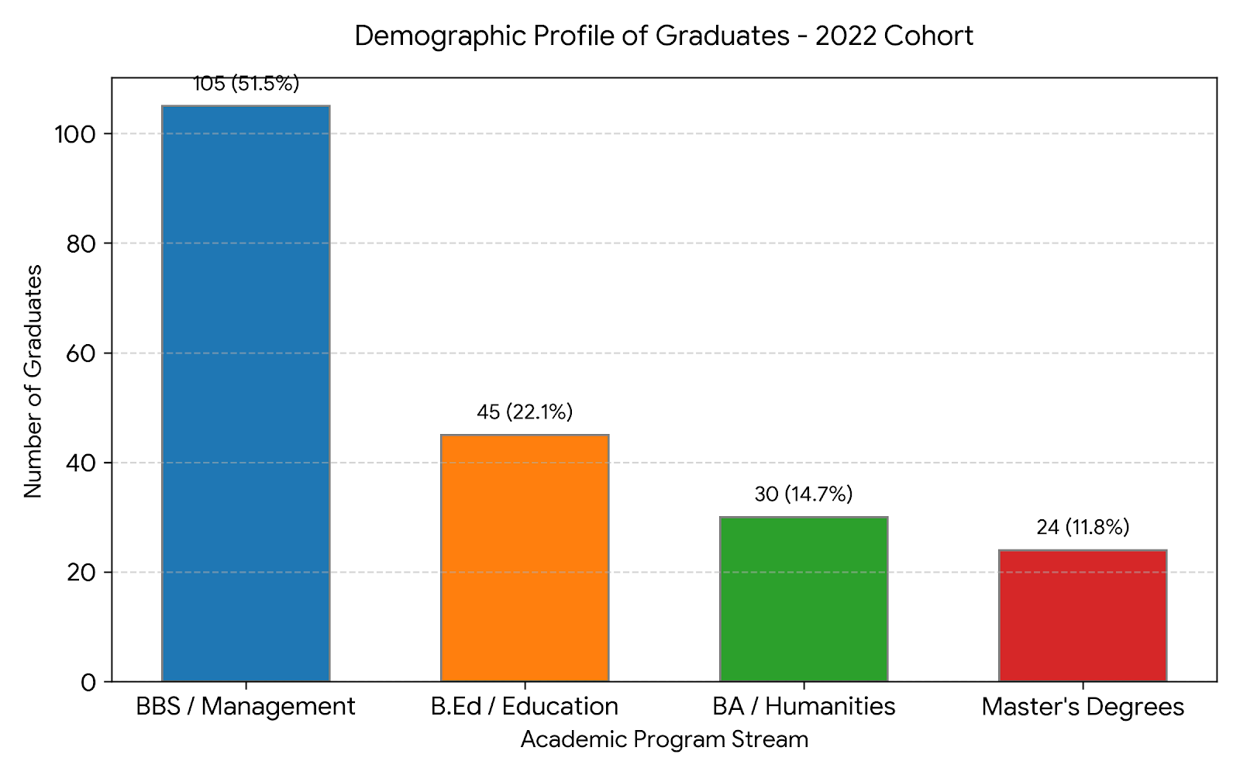

2. 3 Demographic Profile of Graduates — 2023

The 2023 cohort recorded 199 graduates. This cohort features a much more balanced enrollment paradigm, highlighting significant progress in educational development fields within the regional community.

Table 1.3: Academic Stream Distribution (2023)
Faculty / Program Stream | Degree Level | Number of Graduates | Cohort Share (%)
Management | (BBS) | 90 | 45.2%
Education | (B.Ed) | 71 | 35.7%
Humanities | (BA) | 23 | 11.6%
Post-Graduate | Master's Degrees | 15 | 7.5%
Total Cohort | — | 199 | 100.0%

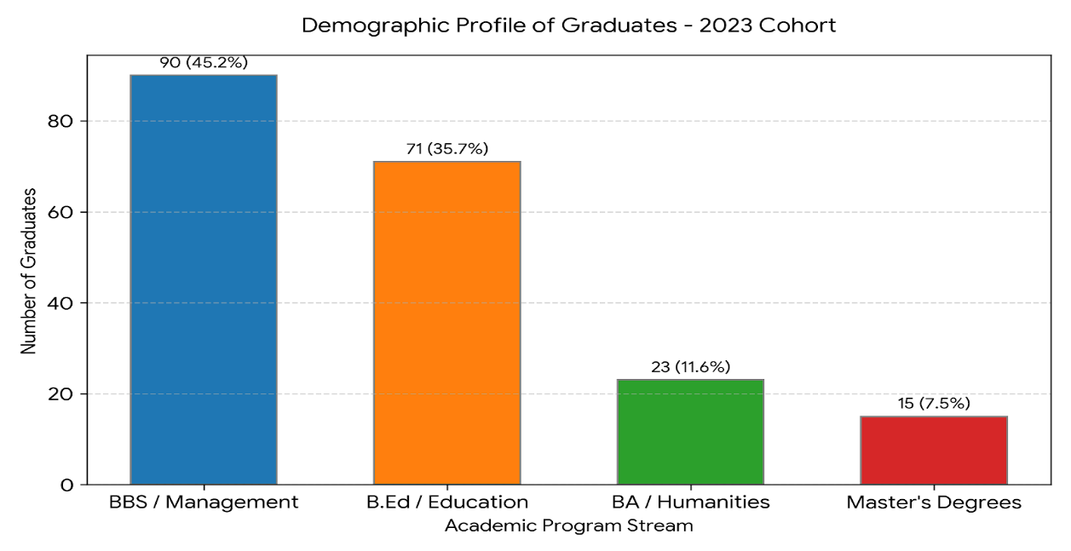

Employment and Further-Study Status
- Market Insertion Rate (54.4%): Out of all the tracking records with clear, documented answers, more than half of the graduates (123 individuals) successfully transitioned into active professional roles. They are primarily employed across schools, public service sectors, and local businesses.
- Unemployment Margin (45.6%): A segment of 103 graduates was recorded as unemployed or looking for opportunities at the time of data collection. This indicates a continuing need for local career support and placement services.
- Tracking Gap (55.0%): Over half of the tracked dataset (276 individuals) did not submit or have an active update regarding their professional placement. This is a common pattern in post-graduation tracking datasets, highlighting that the true employment figure may be much higher once non-respondent updates are collected.

Table: Employment Status Distribution
Employment Status | Number of Graduates | Share of Total Cohorts (%) | Share of Disclosed Responses (%)
Employed | 123 | 24.5% | 54.4%
Unemployed | 103 | 20.5% | 45.6%
Not Disclosed / Unknown | 276 | 55.0% | —
Total Processed Records | 502 | 100.0% | 100.0%
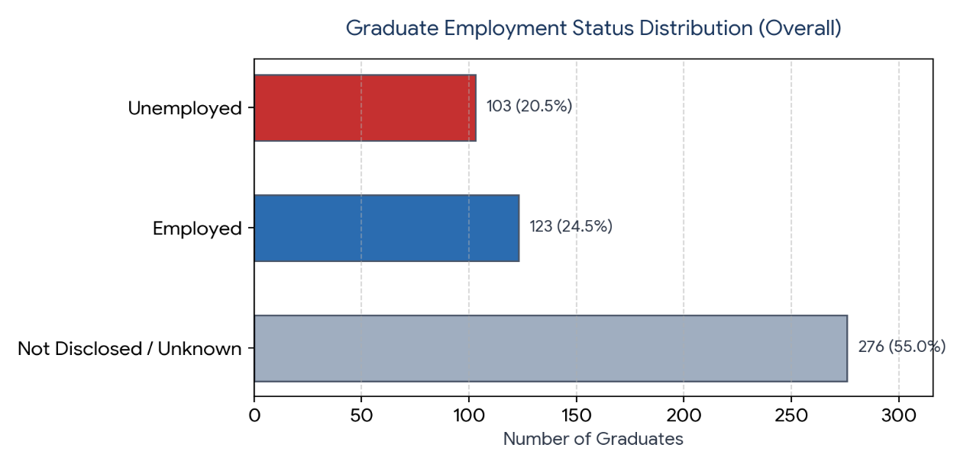

2.5 Further Study Status Metrics
- Academic Progression Rate (43.7%): Out of all the tracking records containing explicit responses, 87 graduates chose to advance their academic paths. This includes 83 individuals currently enrolled in advanced Master's programs (such as MBS, M.Ed, or MA tracks) and 4 individuals who have already successfully completed their postgraduate degrees.
- Workforce Only Focus (56.3%): A total of 112 graduates were confirmed as "Not Enrolled" in further institutional studies. This segment indicates individuals who completed their degrees and immediately focused on entering the competitive job market or pursuing non-academic vocational training rather than immediate educational progression.
- Information Availability Gap (60.4%): A majority of 303 tracking records did not report a confirmed enrollment status. This suggests that continuing education milestones are frequently left un-updated once a student exits campus unless they choose to explicitly register for a postgraduate program within the same regional university ecosystem.
Below is the comprehensive summary table, standalone chart, and logical analysis breakdown of the continuing education and higher study metrics for the graduate cohorts.

Table: Further Study Status Distribution
Higher Education Status | Number of Graduates | Share of Total Cohorts (%) | Share of Disclosed Responses (%)
Enrolled in Further Studies | 83 | 16.5% | 41.7%
Not Enrolled | 112 | 22.3% | 56.3%
Completed Higher Degree | 4 | 0.8% | 2.0%
Not Disclosed / Unknown | 303 | 60.4% | —
Total Processed Records | 502 | 100.0% | 100.0%

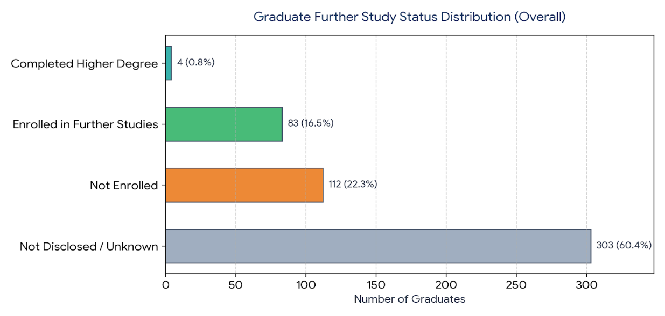

2.6 Socio-Demographic Equity in Access
The socio-demographic distribution of the graduates provides insight into how accessible higher education is across gender lines and socio-cultural groups within the region.
- Strong Female Enrollment (73.3%): The data reveals that females make up the vast majority (368 graduates) of the cohort. This high number shows the campus plays a major role in expanding higher education for women in the region, providing accessible academic options closer to home.
- Dominance of Regional Khas Arya Groups (86.1%): Graduates from Khas Arya backgrounds (predominantly Brahmin and Chhetri communities) form the largest group with 432 individuals. This aligns with the overall demographic makeup of the Far-Western hills and plains.
- Marginalized Communities and Indigenous Groups (14.0%): Together, Janajati students (primarily Indigenous Tharu and Rana communities) and Dalit students make up 14.0% of the graduates (70 individuals). While this indicates the campus is drawing a diverse student body, the lower numbers compared to regional population shares highlight an ongoing need for targeted scholarships, outreach programs, and support services to ensure more equitable access.

1. Demographic Representation Tables

Table A: Gender Equity Metrics
Gender Group | Number of Graduates | Share of Total Enrolled Cohorts (%)
Female | 368 | 73.3%
Male | 134 | 26.7%
Total | 502 | 100.0%

Table B: Socio-Cultural / Ethnic Diversity Metrics
Socio-Cultural Group | Key Represented Surnames  in Cohort | Graduate Count | Representation (%)
Khas Arya | Joshi, Awatshi, Chand, Ojha,  Saud, Bist, Karki, Bhatta | 432 | 86.1%
Janajati (Tharu/Rana) | Chaudhary, Tharu, Rana, Magar,  Gurung, Shrestha | 46 | 9.2%
Dalit | BK, Tamata, Lohar, Sarki, Kami,  Damai, Pariyar, Kshedal | 24 | 4.8%
Total | — | 502 | 100.0%

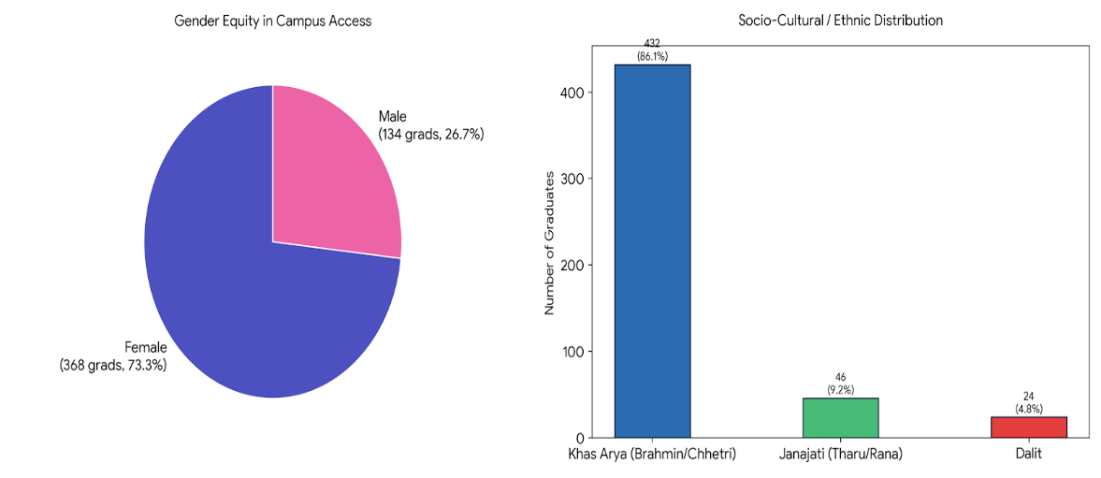

2.7 Graduate Employment Trends
Analyzing employment metrics across consecutive graduation cohorts (2021 to 2023) reveals patterns in how graduates transition into the regional labor market. Growth in Market Absorption (2021–2023): The absolute number of successfully employed graduates more than tripled over this period, growing from 18 individuals in 2021 to 71 individuals in 2023.
    - Upward Rate Spike in 2023: The effective employment rate held steady between 2021 (48.6%) and 2022 (47.9%), followed by a notable increase to 60.2% in 2023. This change suggests a stronger local job market, increased hiring within educational institutions (such as secondary school teachers), or more proactive career tracking.
    - Persistent Competitive Challenges: Despite rising employment figures, the number of active job seekers also expanded, reaching 47 unemployed individuals in 2023. This trend points to a growing cohort size and underscores the value of expanding local professional opportunities, civil service preparation groups, and institutional career placement support.

2.7.1 Employment Trends Summary Table
The table below outlines the total raw counts alongside the Effective Employment Rate, which is calculated based strictly on graduates who provided a definitive status (excluding non-disclosed records).
Graduation Year | Employed | Unemployed | Not Disclosed | Total Tracked | Effective Employment Rate (%)
2021 Cohorts | 18 | 19 | 82 | 119 | 48.6%
2022 Cohorts | 34 | 37 | 111 | 182 | 47.9%
2023 Cohorts | 71 | 47 | 83 | 201 | 60.2%
Cumulative Total | 123 | 103 | 276 | 502 | 54.4% (Average)
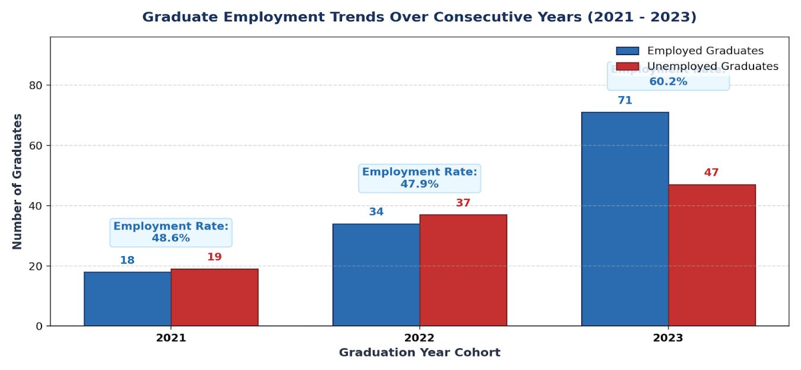

Chapter 5: Discussion

The analysis indicates a notable growth in market absorption of graduates, with the number of successfully employed individuals increasing significantly from 18 in 2021 to 71 in 2023. While the employment rate remained relatively stable at 48.6% in 2021 and 47.9% in 2022, a substantial improvement was observed in 2023, where it rose to 60.2%. This positive trend suggests the emergence of a more robust local job market, potentially driven by increased hiring in sectors such as educational institutions, along with improvements in proactive career tracking mechanisms. However, despite these gains, ongoing challenges persist, as the number of graduates actively seeking employment has also increased, reaching 47 individuals in 2023. This highlights the continued need for strengthened career placement services and support for civil service preparation. Furthermore, it is important to note a significant data limitation, as 276 records representing 55.0% of the total processed data did not disclose their employment status, indicating that the actual employment figures may be higher than reported.

Socio-Demographic Transformations and Equity in Access
The campus plays a significant role in expanding access to higher education, particularly for women in the region. Female graduates constitute the majority of the cohort, with 368 individuals accounting for 73.3% of total enrollment, while male graduates number 134, representing 26.7%. This high level of female participation highlights the campus as a vital hub that enables women to pursue academic degrees closer to home, thereby supporting their transition into professional careers or further studies. In terms of ethnic composition, the Khas Arya group forms the largest segment of graduates, comprising 86.1%, which reflects the broader demographic distribution of the region. Meanwhile, Janajati and Dalit communities including Tharu, Rana, and other Dalit groups collectively represent 14.0% of the graduates. Although the campus serves a diverse student population, the relatively lower representation of marginalized and indigenous groups compared to their regional population share indicates the need for targeted institutional interventions. To promote greater equity and inclusion, it is recommended that the campus implement focused outreach programs, expand scholarship opportunities, and provide dedicated support services to enhance access and success for underrepresented communities.

The Proliferation of Academic Continuation over Employment

The findings reveal a strong inclination toward continued education among graduates, with 43.7% (87 individuals) of those with explicit tracking responses pursuing further studies. Within this group, the majority 83 individuals are currently enrolled in Master’s programs such as MBS, M.Ed, or MA, while 4 individuals have already completed advanced degrees. This trend indicates that, for many graduates, a bachelor’s degree serves as a stepping stone toward specialized postgraduate qualifications rather than a terminal academic endpoint. In contrast, 112 graduates (56.3% of those with disclosed statuses) were categorized as “Not Enrolled,” reflecting a conscious decision to enter the workforce directly or pursue non-academic vocational pathways. However, the overall interpretation of these trends is constrained by significant data limitations, as 303 records (60.4% of the total cohort) did not report confirmed enrollment status. Furthermore, the report suggests that academic progression is often underreported, particularly when students enroll in postgraduate programs outside the regional university system, leading to a likely underestimation of the true rate of continued education.

Labor Market Disparities and Gendered Transitions

The analysis of gendered transitions and market engagement reveals a predominantly female student cohort, with 368 female graduates (73.3%) compared to 134 male graduates (26.7%), highlighting the campus’s critical role in supporting women’s access to higher education. However, a significant tracking gap remains a major limitation, as 276 records (55.0% of total processed data) did not disclose updated employment status, thereby obscuring a comprehensive understanding of labor market outcomes across gender and socio-cultural groups. Among the disclosed records, 123 graduates (54.4%) successfully transitioned into professional roles, while a substantial proportion 103 graduates (45.6%) were either unemployed or actively seeking employment at the time of data collection. Despite these challenges, positive labor market trends are evident, with the number of employed graduates increasing markedly from 18 in 2021 to 71 in 2023. Correspondingly, the effective employment rate improved significantly, rising from approximately 48% in 2021 and 2022 to 60.2% in 2023. Nevertheless, the simultaneous growth in the number of job seekers underscores the continued need for targeted institutional support, including strengthened career services, job placement initiatives, and civil service preparation programs, to better equip graduates in navigating an increasingly competitive labor market.

Programmatic Performance, Alignment, and Curricular Relevance
The analysis of programmatic performance and institutional shifts reveals moderate fluctuations in graduation trends over the three-year period, with total graduates declining slightly from 223 in 2021 to 204 in 2022 and 199 in 2023. Alongside this, a notable diversification of academic streams has taken place, indicating a move toward more balanced enrollment. In 2021, the Management stream overwhelmingly dominated with 74.0% of graduates; however, by 2023, its share decreased significantly to 45.2%. In contrast, the Education faculty experienced substantial growth, rising from 10.8% of the cohort in 2021 to 35.7% in 2023, suggesting a strategic institutional alignment with regional educational demands. This shift is further supported by improving labor market outcomes, as the effective employment rate increased from 48.6% in 2021 to 60.2% in 2023, indicating that the curriculum is becoming increasingly relevant to local labor market needs. Graduates are primarily securing employment in sectors aligned with their academic training, including local schools, public service, and small businesses. Additionally, the curriculum supports continued academic progression, with 43.7% of respondents with disclosed data pursuing higher education in specialized programs such as MBS, M.Ed, and MA. Despite these positive developments, a significant tracking gap persists, with over 55% of employment data and 60% of higher education status records remaining undisclosed, thereby limiting the institution’s ability to comprehensively evaluate the long-term effectiveness and impact of its academic programs on graduate outcomes.

Summary of Strategic Implications

The transition from a Management-dominated cohort to a more diversified academic landscape necessitates the adoption of faculty-specific career strategies to enhance employment absorption. The Management faculty (BBS), which has historically constituted the largest share of graduates, now requires a strategic shift toward strengthening practical and market-oriented skills such as accounting software proficiency, business communication, and applied financial practices to ensure competitiveness in banking, corporate, and public service sectors. In contrast, the Education faculty (B.Ed), which has experienced substantial growth from 10.8% in 2021 to 35.7% in 2023, has emerged as a cornerstone of the institution. Strategic efforts in this faculty should prioritize formal partnerships with regional schools and educational institutions to facilitate a smoother transition of graduates into teaching professions. Meanwhile, the Humanities faculty (BA), which prepares students for diverse career pathways including civil service, non-governmental organizations, and emerging digital sectors, requires enhanced career counseling that emphasizes diversified vocational training, skill development, and structured preparation for public sector examinations.
In terms of employment trends, the improvement in the effective employment rate to 60.2% in 2023 indicates positive alignment between academic programs and labor market demands. However, the relatively high proportion of graduates (45.6% of disclosed cases) who are unemployed or actively seeking employment highlights the urgent need for strengthened career placement services and institutional support mechanisms. A major strategic challenge remains the substantial tracking gap, with 276 employment records and 303 further study records undisclosed. This limitation restricts the institution’s ability to accurately assess graduate outcomes and program effectiveness. Therefore, improving graduate tracking systems is essential to distinguish between employment, further education, and unemployment outcomes. Additionally, the presence of dual pathways among graduates. Where approximately 44% pursue further studies while others enter the workforce, suggests the need for a balanced institutional approach. This should include continued support for academic progression through postgraduate pathways alongside robust vocational and career placement support for immediate labor market entry.

Conclusion
The analysis of employment trends indicates a positive trajectory in graduate market absorption, with the number of successfully employed graduates increasing significantly from 18 in 2021 to 71 in 2023. This improvement is further reflected in the effective employment rate, which rose to 60.2% in 2023 from approximately 48% in the preceding years, demonstrating a growing alignment between academic programs and labor market demands. However, despite these gains, a considerable unemployment margin persists, with 45.6% of graduates (among those who disclosed their status) either unemployed or actively seeking employment. This underscores the continued need for targeted career placement initiatives, enhanced employability training, and structured civil service preparation support.
In parallel, the findings reveal a strong commitment to academic progression among graduates. Approximately 43.7% of respondents with disclosed data (87 individuals) are either currently enrolled in or have completed higher education programs such as Master’s degrees (e.g., MBS, M.Ed), indicating that undergraduate education is widely perceived as a pathway to advanced specialization. Conversely, 56.3% of graduates reported not pursuing further studies, reflecting a direct transition into the labor market and highlighting the dual pathways followed by graduates.
Faculty-specific trends further enrich this analysis. While the Management (BBS) program has historically dominated graduate output, the rapid growth of the Education faculty reaching 35.7% of the cohort in 2023, signals a strategic alignment with regional demand for qualified educators.
Despite these encouraging trends in both employment and academic continuation, a critical limitation remains in the form of a substantial tracking gap. With 55.0% of employment records (276 individuals) and a similarly large proportion of further study data undisclosed, the institution faces challenges in accurately assessing graduate outcomes and satisfaction. Therefore, strengthening graduate tracking systems and developing comprehensive alumni databases is essential for informed decision-making. Moving forward, the institution should focus on bridging this data gap while continuing to implement faculty-specific career support strategies to enhance both employment outcomes and academic progression.

References
Aryal, R. (2021). Graduate employment and career satisfaction in Kathmandu Valley: A study of university graduates. Tribhuvan University Press.
Bandura, A. (1997). Self-efficacy: The exercise of control. Freeman.
Becker, G. S. (1964). Human capital: A theoretical and empirical analysis, with special reference to education. University of Chicago Press.
Bennett, R., Eagle, L., & Clewes, D. (2015). Graduate employability and work-integrated learning in Europe: Evidence from five countries. European Journal of Education, 50(2), 147–164. https://doi.org/10.1111/ejed.12102
Birendra Multiple Campus Report. (2025). Tracer study of graduates 2021–2025.
Birendranagar, Nepal: Birendra Multiple Campus Publication.
Bista, K. (2020). Graduate employability in Nepalese higher education. Higher Education Review, 52(2), 45–60.
Brown, P., Hesketh, A., & Williams, S. (2003). Employability in a knowledge-driven economy. Routledge.
Chhetri, R., & Sedai, K. (2019). Tracer study of graduates: Employability and skills in Tribhuvan University-affiliated campuses. Journal of Education and Development, 4(1), 23–38. https://doi.org/10.3126/jed.v4i1.2929
Cranmer, S. (2006). Enhancing graduate employability: Best intentions and mixed outcomes. Studies in Higher Education, 31(2), 169–184. https://doi.org/10.1080/03075070600572041
Dacre Pool, L., & Qualter, P. (2018). Emotional intelligence and employability: A framework for graduate success. Routledge.
Fugate, M., Kinicki, A. J., & Ashforth, B. E. (2004). Employability: A psycho-social construct, its dimensions, and applications. Journal of Vocational Behavior, 65(1), 14–38. https://doi.org/10.1016/S0001-8791(03)00059-7
Gautam, S. (2025). Employment patterns and career satisfaction of graduates: Evidence from Kalika Multiple Campus. Kalika Multiple Campus Publication.
Green, F., & McIntosh, S. (2007). Is there a graduate wage premium? Evidence from the UK. Economics of Education Review, 26(6), 642–654. https://doi.org/10.1016/j.econedurev.2006.06.002

Greenhaus, J. H., Parasuraman, S., & Wormley, W. M. (1990). Effects of race on organizational experiences, job performance evaluations, and career outcomes. Academy of Management Journal, 33(1), 64–86. https://doi.org/10.5465/256352
Gurung, S., & Shrestha, P. (2022). Career satisfaction of graduates in Nepal: A comparative study. Nepalese Journal of Educational Research, 12(2), 45–62.
Gyawali, R. (2025). Employability capital and perceived graduate outcomes in Nepalese universities. Pokhara University Press.
Harvey, L. (2010). Defining and measuring employability. Quality in Higher Education, 7(2), 97–109.
Herzberg, F., Mausner, B., & Snyderman, B. B. (1959). The motivation to work (2nd ed.).
Wiley.
Khadka, B. (2025). Determinants of graduate employability in Nepalese higher education institutions. Kathmandu University Publication.
King, R., & Palmer, R. (2010). Internationalizing higher education: The role of graduate tracer studies. Routledge.
Knouse, S., Tanner, J., & Harris, E. (2013). The impact of internships on career success. Journal of Employment Counseling, 50(1), 2–11. https://doi.org/10.1002/j.2161-1920.2013.00020.x
Pool, L. D., & Sewell, P. (2007). The key to employability: Developing a practical model of graduate employability. Education + Training, 49(4), 277–289. https://doi.org/10.1108/00400910710754435
Schomburg, H. (2016). Carrying out tracer studies: Guide to anticipating and matching skills and jobs. European Training Foundation.
Schomburg, H. (2016). Trends in graduate employment studies. CHE Consult.
Sharma, R. (2023). Employability of engineering graduates in Nepal: Employer perspectives. Nepal Journal of Science and Technology, 24(1), 15–28.
Shrestha, P. (2021). Skills mismatch and graduate unemployment in Nepal. Journal of Education and Work, 34(3), 289–304.
Shrestha, A. (2025). Information and communication technology graduates’ employability in Nepal. Pokhara University Press.
Tomlinson, M. (2012). Graduate employability and career development learning: An international perspective. Journal of Education and Work, 25(1), 1–20. https://doi.org/10.1080/13639080.2012.708751

Tomlinson, M. (2017). Forms of graduate capital and their relationship to graduate employability. Education + Training, 59(4), 338–352. https://doi.org/10.1108/ET-05-2016-0090
Tracer Study Report. (2025). Graduate employment and satisfaction report: Multi-campus survey 2021–2025. Nepal Higher Education Council.
Van de Wende, M. (2016). Tracer studies and graduate outcomes. Educational Assessment Review.
Wilton, N. (2012). Do employability skills really enhance graduate employment?
Education + Training, 54(4), 263–279. https://doi.org/10.1108/00400911211231354
Kristof-Brown, A. L., Zimmerman, R. D., & Johnson, E. C. (2005). Consequences of individuals' fit at work: A meta-analysis of person-job, person-organization, person- group, and person-supervisor fit. Personnel Psychology, 58(2), 281–342. https://doi.org/10.1111/j.1744-6570.2005.00672.x
Nepal, P. (2023). Graduate employment trends in multiple campuses of Nepal: A case study of Kalika Multiple Campus. National Education Journal.
Ng, T. W. H., & Feldman, D. C. (2015). The relationships of age with job satisfaction and career satisfaction. Journal of Vocational Behavior, 85, 16–27.
Panthee, S. (2025). Perceived employability skills of diploma graduates in Kathmandu Valley: A comparative study (Unpublished M.Phil. dissertation). Tribhuvan University, Kathmandu, Nepal.
Yorke, M. (2006). Employability in higher education: What it is – what it is not. Higher Education Academy.

Appendices

Appendix I: Sample Survey Questionnaire
Tracer Study Survey for Graduates of Durgalaxmi Multiple Campus (2021–2023) Introduction:
Dear Graduate,
This survey is part of a research study on employment trends and career satisfaction of Durgalaxmi Multiple Campus graduates. Your participation is voluntary, and your responses will remain confidential. The information collected will be used solely for research purposes and will help improve academic programs and career support at the campus. Please answer all questions honestly.

Section A: Personal and Academic Information
- Full Name (Optional):
- Gender: Male / Female / Other
- Year of Graduation: 2021 / 2022 / 2023
- Program Completed: Bachelor’s / Master’s
- Field of Study:
- Contact Information (Email/Phone for follow-up if needed):

Section B: Employment Status
- Are you currently employed? Yes / No
- If yes, what is your employment type? Full-time / Part-time / Contractual / Temporary / Self-employed
- Sector of employment: Public / Private / NGO / Self-employed / Other (please specify)
- Job title/position:
- Duration between graduation and first employment: Less than 3 months / 3–6 months / 6–12 months / More than 12 months
- Is your current job related to your field of study? Yes / No / Partially
- Please describe briefly how your current job relates to your academic program:

Section C: Career Satisfaction
- How satisfied are you with your current career overall? Very Satisfied / Satisfied / Neutral / Dissatisfied / Very Dissatisfied
- How satisfied are you with the following aspects of your career? (Rate each on a 5-point scale: 5 = Very Satisfied, 1 = Very Dissatisfied)

  - Salary and benefits: 5 / 4 / 3 / 2 / 1
  - Opportunities for professional growth: 5 / 4 / 3 / 2 / 1
  - Work-life balance: 5 / 4 / 3 / 2 / 1
  - Job security: 5 / 4 / 3 / 2 / 1
  - Relevance of education to your work: 5 / 4 / 3 / 2 / 1
- To what extent do you feel your academic program prepared you for your current employment? Very Well / Well / Neutral / Poorly / Very Poorly
- Would you recommend your program at Durgalaxmi Multiple Campus to future students based on career preparation? Yes / No / Not Sure

Section D: Career Challenges and Suggestions
- What were the main challenges you faced in finding a job after graduation? (You may select more than one)
  - Lack of vacancies in the field
  - Lack of relevant skills
  - Limited professional networks
  - Inadequate guidance from the institution
  - Others (please specify)
- What improvements or support services from the campus could help graduates improve employability and career satisfaction?
- Any additional comments regarding your employment experience or career satisfaction: _

Appendix II: Sample Consent Letter for Participation

Consent Letter for Survey Participation
Dear Graduate,
You are invited to participate in a research study conducted by Durgalaxmi Multiple Campus to understand the employment trends and career satisfaction of graduates from 2021 to 2023. This study uses a quantitative survey design through a tracer study and aims to collect information on employment status, job types, relevance of academic programs, and overall career satisfaction.
Purpose of the Study: The purpose of this research is to track the career paths of graduates, identify employment trends, assess career satisfaction, and provide insights to improve academic programs and career services at the campus.
Participation: Your participation in this survey is completely voluntary. You have the right to refuse participation or withdraw at any point without any negative consequences.
Confidentiality: All information provided will be kept strictly confidential. Your personal identity will not be disclosed in any reports or publications. Data will be reported in aggregate form only.
Procedure: The survey will take approximately 10–15 minutes to complete. You will be asked questions about your educational background, employment status, job characteristics, career satisfaction, and related experiences.
Benefits: While there may be no direct personal benefit to you, your participation will contribute valuable information to improve the relevance of academic programs and career services at Durgalaxmi Multiple Campus, benefiting future graduates.
Contact: If you have any questions about the study, you may contact the principal investigator at bhattasabu@gmail.com or 9848534661.
By completing and submitting this survey, you are providing your informed consent to participate in this study.
Thank you for your valuable time and contribution.

Sincerely,
Researcher: Sabitri Bhatta
Durga Khadka
Durgalaxmi Multiple Campus, Attariya, Kailali, Nepal

